Windows Server 2022 Install using VMware
- Open your VMware and click create, then select custom (advanced)
Click next until you will have to choose or create a location for your server
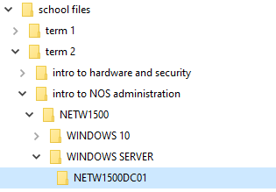
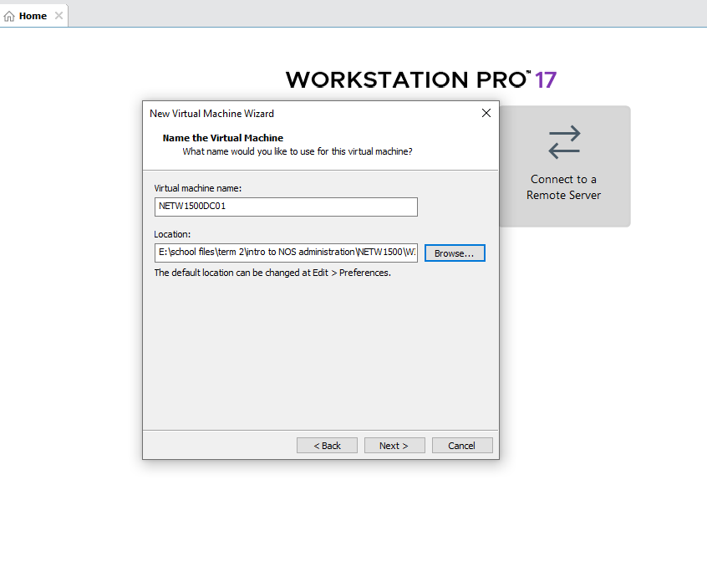
- After the first step just click next and leave that as defaults.
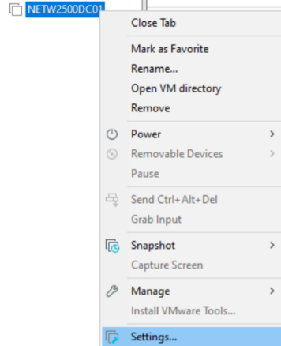
Then when you click finish, right click and go to settings.

- Select CD/DVD(SATA), and click the “Use ISO image file” and click browse.
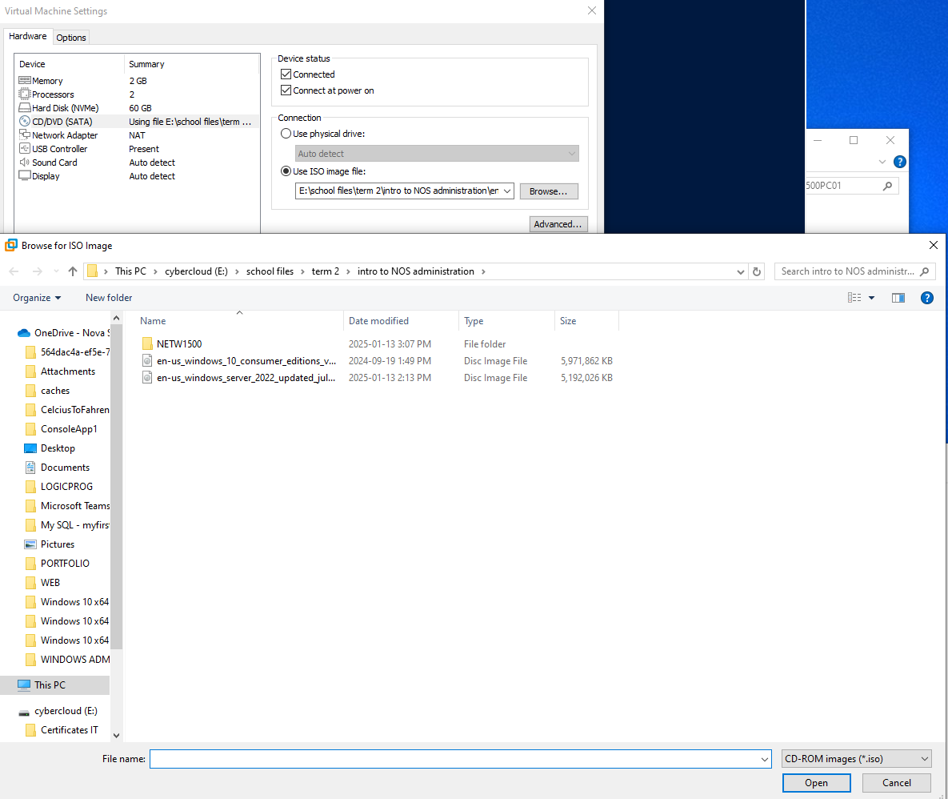
then select the windows server 2022 iso from your external drive
- Click on Power On to firmware
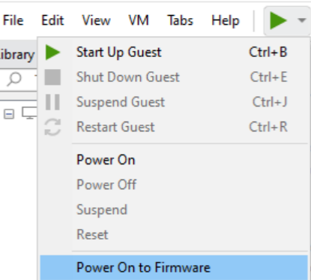

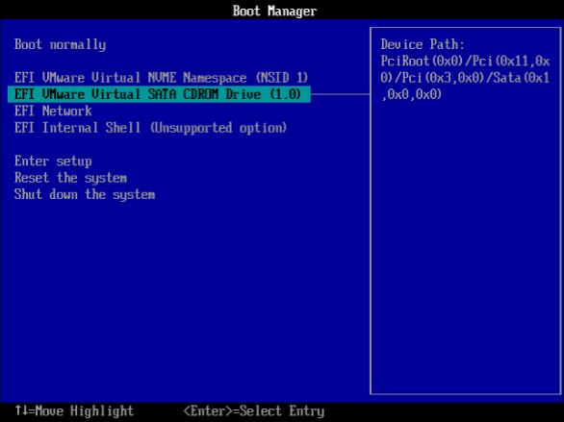
- choose EFI VMware Virtual SATA CDROM Drive (1.0)
then click enter.
- click next, and your screen will look like this.
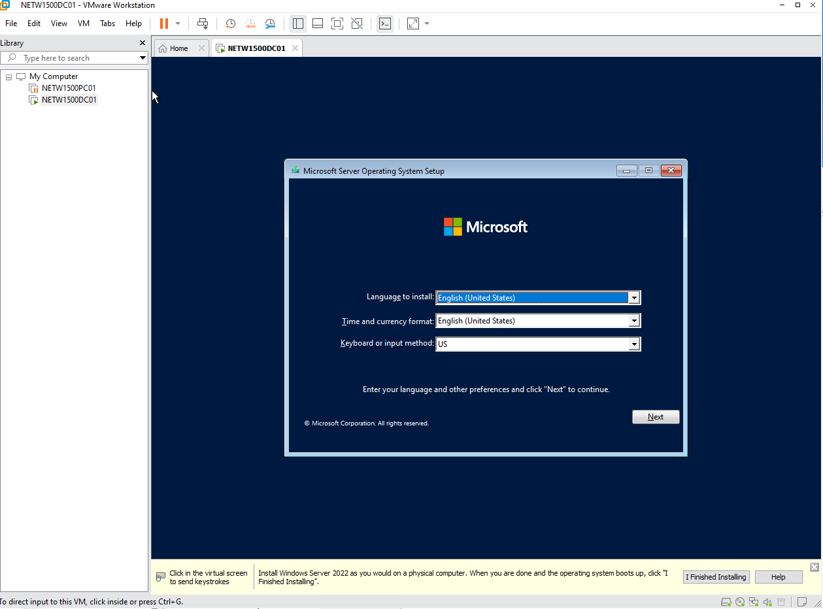
Then click next again.

- click install now

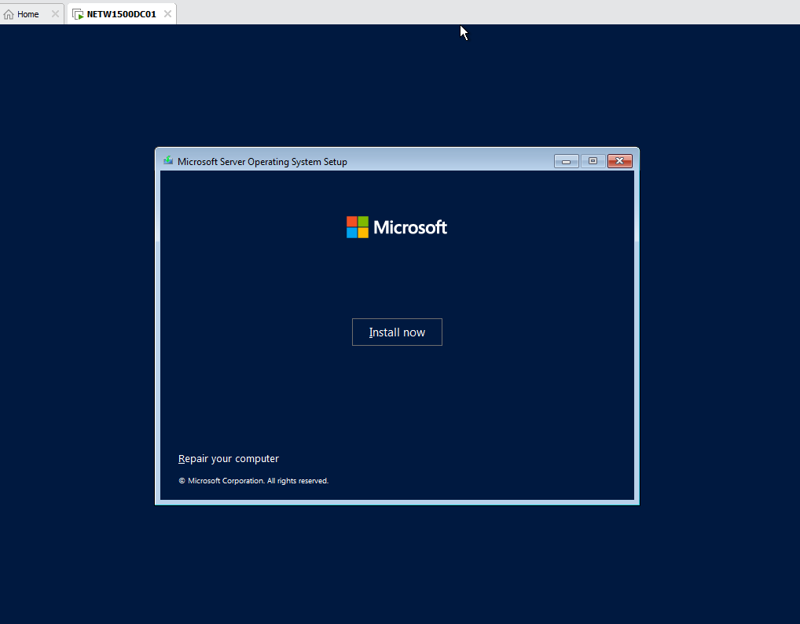
- Get the product key from the portal.azure.com where you downloaded the windows server 2022 iso.
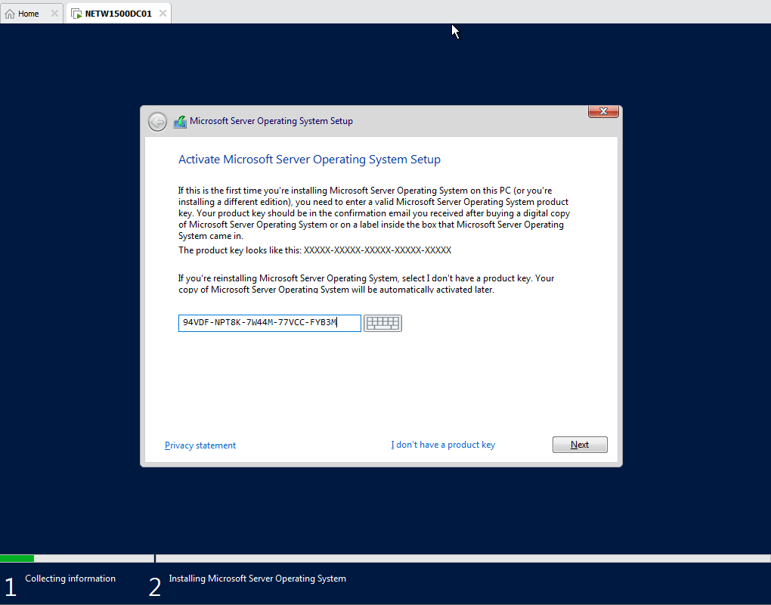

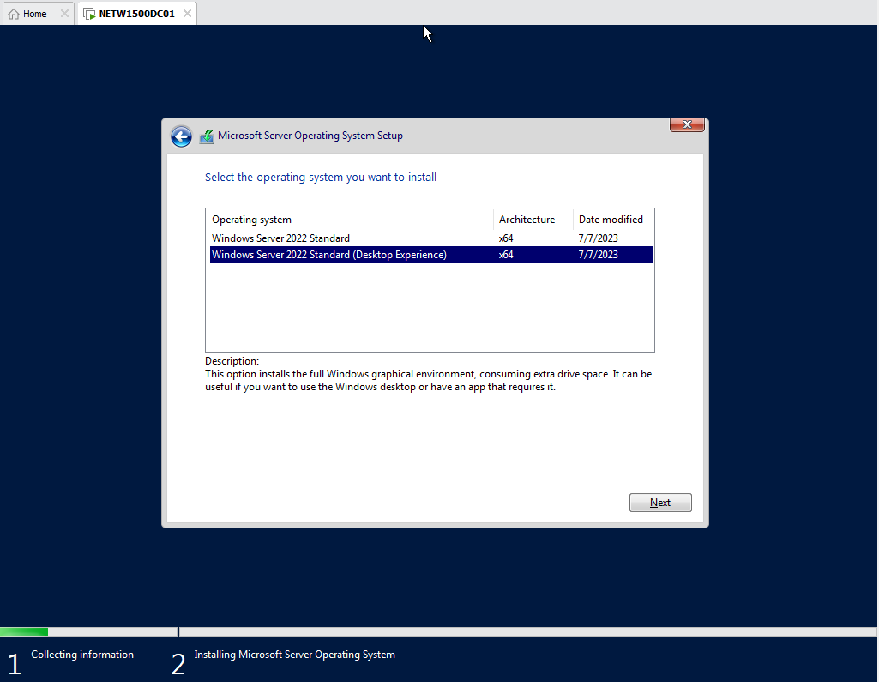
- choose the standard (desktop experience) and click next

- Click the accept checkbox
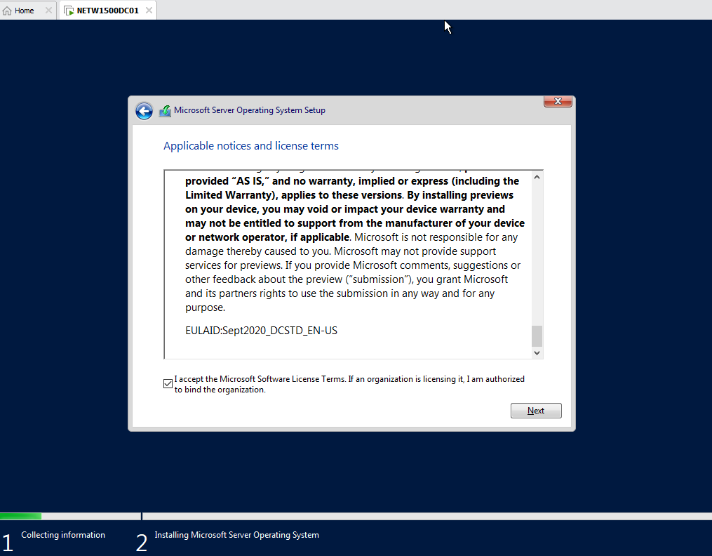

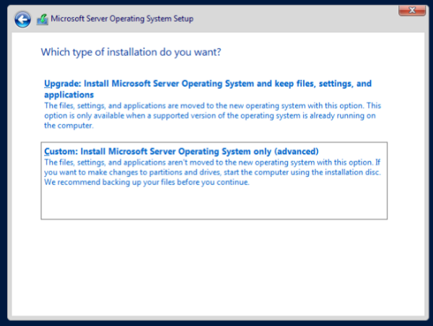
- select the custom install

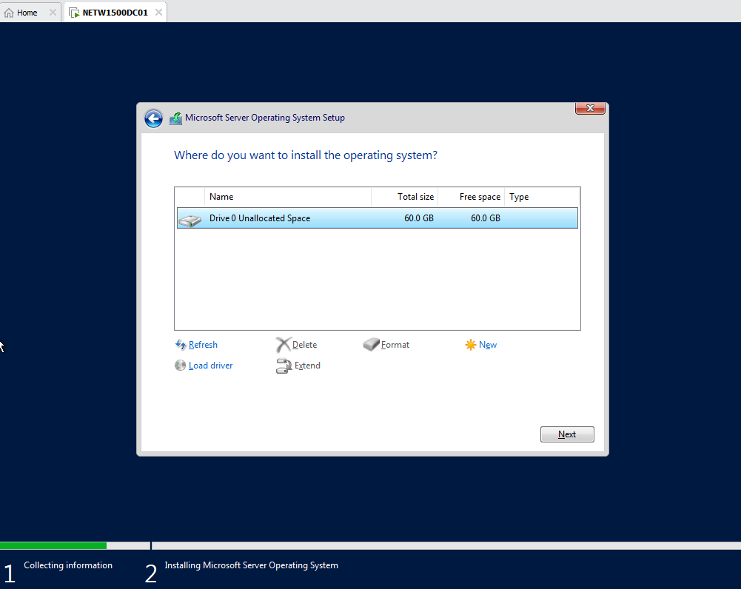
- click next

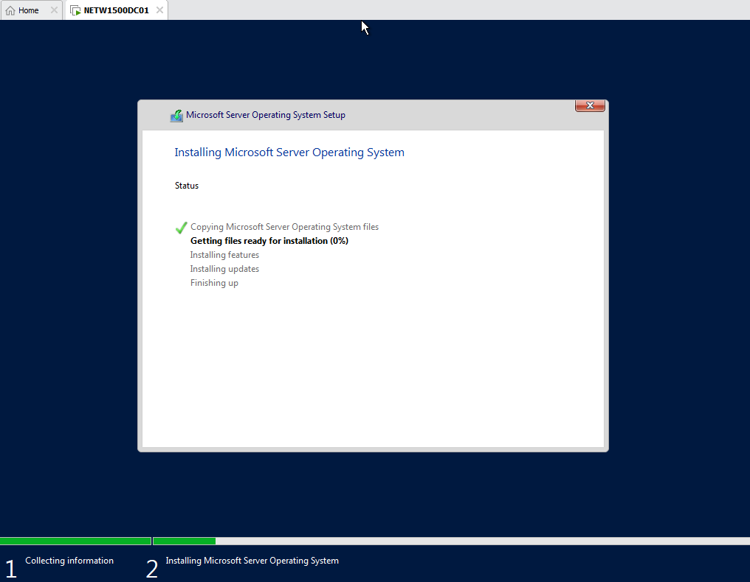
- wait for the installation to load

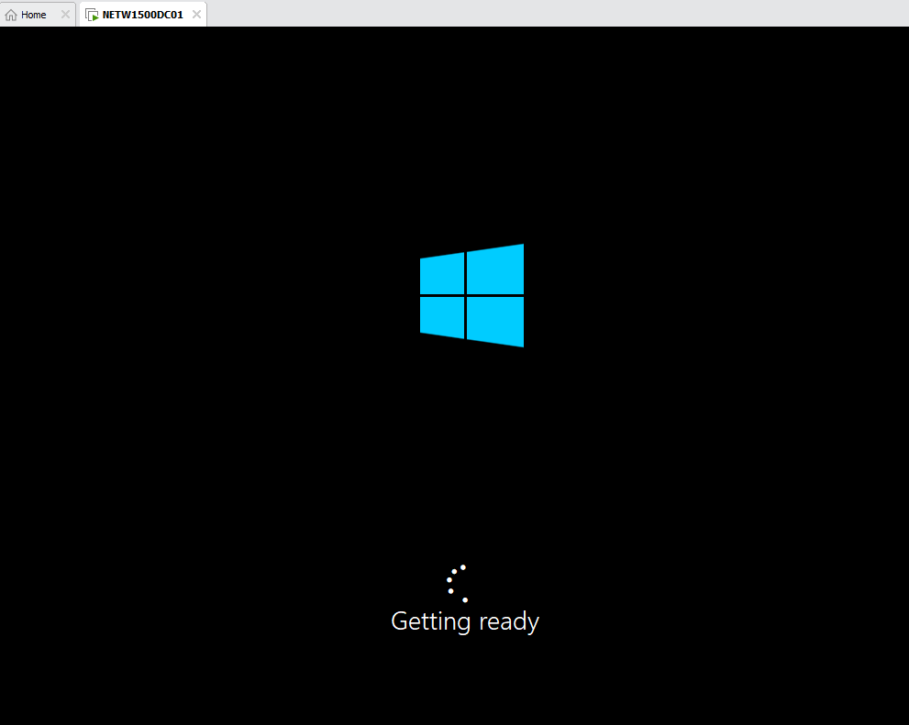
- after installation your screen will load like this

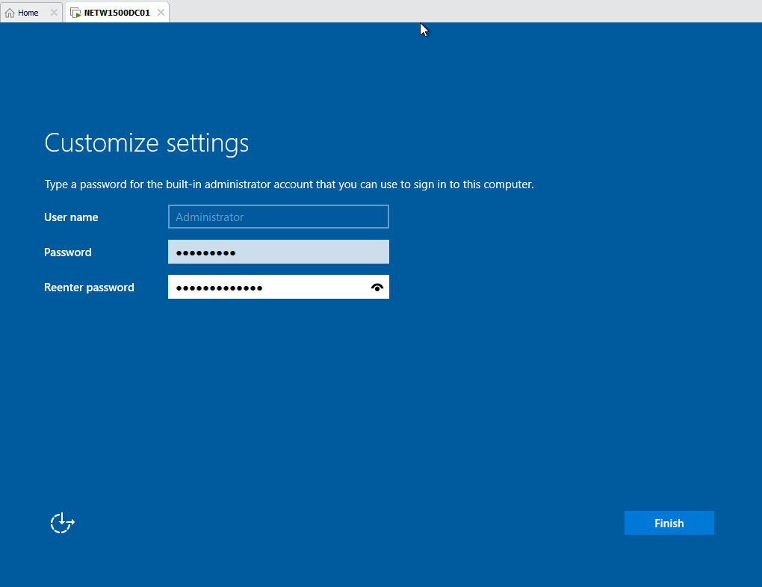
- Set your Administrator password as Student#1
Then click finish

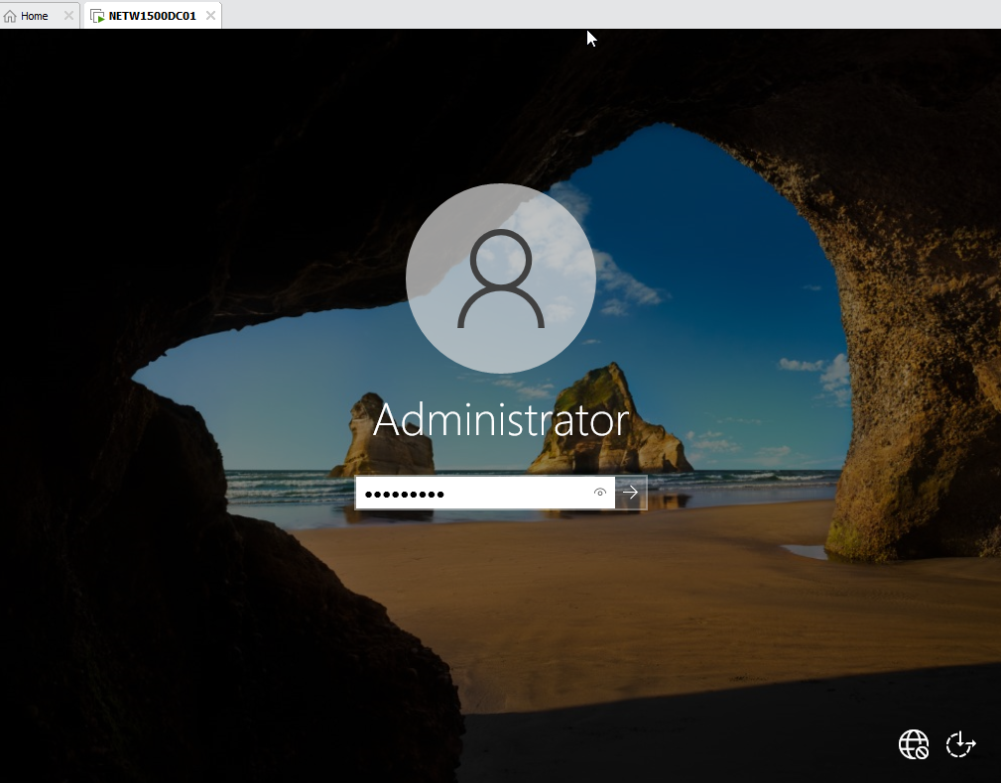
- You are now in your windows server!

- Snapshot your finished installed windows server
